skateCamp getters:

they are used to get the values that have been set for the object skateCamp.

skateCamp setters:

they are used to set the values for the object skateCamp.

Register():

Creates a participant but doesn’t assign it to any of the skate camps

enroll():

assigns the participant to the given camp assuming that it meets all parameters

removeParticipant():

removes a participant from the skatecamp array

quit():

exits the program and prints a thank you message

toString for both classes:

prints the current state of all the object variables

1. 2. *Data Definition Class(es)* - Create a detailed UML Class Diagram, listing and explaining all class variables, accessors, mutators, special purpose methods, and constructors associated to each data definition class.

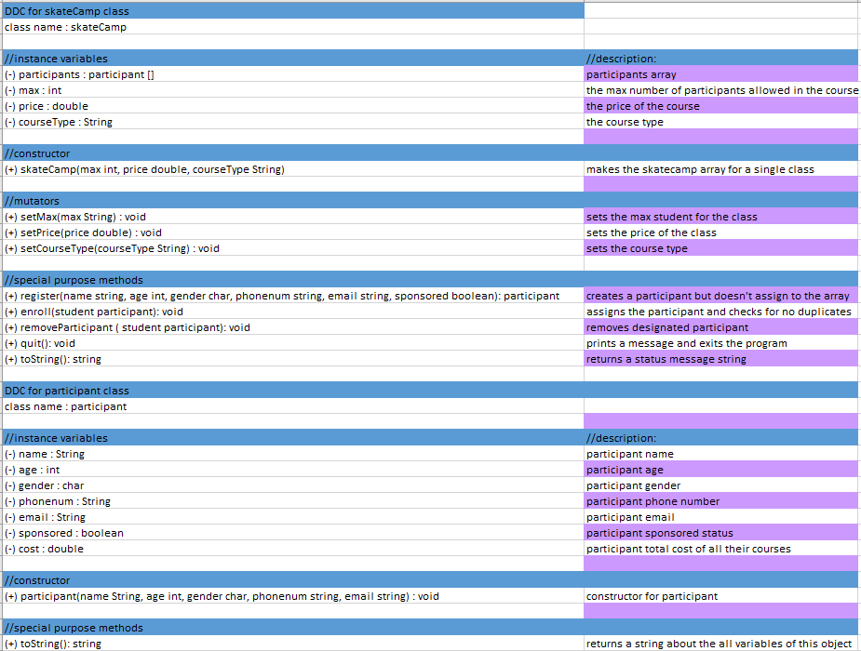

Method: skateCamp

Purpose: constructor for the skateCamp object

Input: max : int, price : double, courseType : String

Return: void

Method: participant

Purpose: constructor for the participant object

Input: name : string, age: int, gender: char, phonenum: string, email: string, sponsored : boolean

Return: void

Method: setMax

Purpose: sets the max number of people allowed in the course

Input: int

Return: void

Method: setPrice

Purpose: sets the price of the course

Input: none

Return: creditHour: int

Method: setCourseType

Purpose: sets the course type from the possible 4

Input: none

Return: void

Method: register

Purpose: creates a participant but doesn't assign to the array

Input: name : string, age :int, gender :char, phonenum :string, email: string, sponsored: boolean

Return: participant

Method: enroll

Purpose: assigns the participant and checks for no duplicates

Input: student : participant

Return: void

Method: removeParticipant

Purpose: removes designated participant

Input: student: participant

Return: void

Method: toString

Purpose: returns a status message string

Input: null

Return: String

Method: participant

Purpose: constructor for participant

Input: name :String, age: int, gender :char, phonenum: string, email: string

Return: void

Method: toString

Purpose: returns creditHour times 670.00

Input: none

Return: String